Online Appendix
Methods
Mice were euthanized by injection of buprenorphine (0.01 mg/kg) and sodium pentobarbital (50 mg/kg) and the corresponding experiments were carried out.
Drugs and treatments
Isoproterenol (Sigma Aldrich) was given as a bolus injection IP to mice after stable base line electrocardiography (ECG) and electrocardiogram recording for 5 to 15 min. Mice were challenged with a dose of 0.2 mg/kg based on the literature (1), which was sufficient to induce a significant increase in heart rate in all groups. A concentration of 10⁻⁸ mol/L isoproterenol was used for in vitro treatments. C12-iE-DAP, lauroyl-γ-D-glutamyl-meso-diaminopimelic acid (iE-DAP; Invivogen) was used as a selective NOD1 agonist (2,3). iE-Lys was employed as inactive iE-DAP analogue (Invivogen). Wild-type cardiomyocytes were perfused for 3 to 5 min with 20 µmol/ml iE-DAP, vehicle (<0.01% DMSO) or an equivalent concentration of the inactive NOD1 agonist iE-Lys (Invivogen), and Ca²⁺ recordings were taken. In some experiments, rabbit cardiomyocytes were incubated for 24 h with 40 µmol/ml of iE-DAP or vehicle (<0.01% DMSO). Nodinhibit-1 (Cayman) was used as a selective NOD1 inhibitor and mice were injected IP with 5 µmol/l Nodinhibit-1 or isovolumic vehicle (<0.01% DMSO) 3 times weekly for 6 weeks. We employed 2 µmol/l KT-5720 (Biomol) and 1 µmol/L KN-93 (Calbiochem) to block PKA and CaMKII phosphorylation, respectively.
Human samples
LV biopsies were obtained from ischemic HF patients during surgery for cardiac transplantation at the A Coruña Hospital. LV biopsies of nonfailing hearts were obtained from unused healthy donor hearts from the A Coruña Hospital-Biobank. The seven individuals with healthy myocardium (3 males and 4 females) had a median age of 48 years. The 12 HF patients (10 males and 2 females) had a median age of 53 and their EF before cardiac transplantation was 21.8 ± 1.9%. Full informed written consent was obtained from the families of all donors.
Cardiomyocyte isolation
Adult male mice were sacrificed and hearts were quickly removed and cannulated via the ascending aorta on a Langendorff perfusion apparatus (3). Retrograde perfusion was initiated with calcium-free Tyrode´s solution containing 0.2 mmol/l EGTA for 2–3 minutes at room temperature, and continued with Tyrode´s solution containing CaCl₂ (0.1 mmol/l) and type II collagenase (1 mg/ml) (Worthington) for 8 to 10 min. When the flux rate increased and the heart pallor was suitable, the heart was taken off the apparatus. The ventricles were cut out, chopped into small pieces, and mechanically dissociated in a thermostatic bath at 37°C in the enzymatic solution. The cell solution was filtered through a nylon mesh (250 µm) and centrifuged at 300 rpm for 3 minutes. The pellet was suspended in Tyrode´s solution containing 0.5 mmol/l CaCl₂ and centrifuged as before. The pellet was then resuspended in Tyrode´s solution containing 1 mmol/l CaCl₂ and maintained at room temperature until use. Tyrode´s solution comprised (in mmol/l): 130 NaCl, 5.4 KCl, 0.5 MgCl₂, 25 HEPES, 0.4 NaH₂PO₄, 22 glucose; pH = 7.4 with NaOH.
Western blot analysis
Cardiomyocytes/cardiac tissues were homogenized in a buffer containing in mmol/l: 50 Tris, 320 sucrose, 1 DTT, and a protease/phosphatase inhibitor cocktail (Sigma-Aldrich). Homogenates were centrifuged at 13,000g for 15 min at 4°C, and cleared supernatants were used for immunoblotting. Proteins were separated on SDS-PAGE gels and then transferred to PVDF membranes. Membranes were blocked with 5% BSA and incubated overnight with the following primary antibodies: SERCA, NCX, phospho-RyR₂ (Ser2815), phospho-RyR₂ (Ser2808) (Badrilla, Leeds, UK), RyR₂ (Affinity Bioreagents), GAPDH (Ambion), NOD1 (R&D Systems), RIP2 (Cell Signalling Tech.) and TNF-α (Abcam). Membranes were then incubated with peroxidase-conjugated secondary antibodies in 5% BSA for 60 min at room temperature. Immunoreactive bands were detected using the GE ECL™ Protein Detection System.
Intracellular calcium imaging
[Ca²⁺]_{i} transients and Ca²⁺ sparks were recorded in intact myocytes loaded with the fluorescent Ca²⁺ dye Fluo-3AM (5 µmol/l) and under control Tyrode´s solution perfusion. To obtain [Ca²⁺]_{i} transients, cells were electrically excited at 2 Hz by field stimulation using two parallel Pt electrodes. Spontaneous Ca²⁺ sparks and waves were obtained in quiescent cells after [Ca²⁺]_{i} transients recordings. SR Ca²⁺ load was estimated by rapid caffeine application (10 mmol/l). Cells were excited at 2 Hz to reach the steady state before caffeine addition. Images were obtained with a Meta Zeiss LSM 710 confocal microscope (40× oil immersion objective with a 1.2 NA) by scanning the cell with an argon laser every 1.54 ms. Fluo-3AM was excited at 488 nm and emitted fluorescence was collected at > 505 nm. Data analysis was performed with homemade routines using IDL software (Research System Inc.). Images were corrected for background fluorescence. The fluorescence values (F) were normalized by the basal fluorescence (F0) in order to obtain the fluorescence ratio (F/F0). Ca²⁺ sparks were detected using an automated detection system and using a criterion that discriminated the detection of false events while detecting most Ca²⁺ sparks. Cardiomyocyte surface area was estimated using optical microscopy and quantified with the LSM Zeiss Image browser. Total spark-mediated Ca²⁺ leak was calculated by multiplying spark frequency × peak × duration × width.
Myocardial infarction model
Mice were anesthetized with ketamine, Imalgene® (70 mg/kg) and xylazine, Rompun® (10 mg/kg) intraperitoneally (IP). Unconscious mice were intubated by tracheostomy and ventilated with a tidal volume 230 µl and respiratory rate 150/minute (miniVent type 845, Harvard Apparatus). A left thoracotomy was performed in the third intercostal space to expose the heart and the left lung, the lung was protected by insertion of a 1-mm-thick Spongostan® sponge lightly moistened with saline, and the pericardium opened. A branch of the coronary artery was ligated with a 6-0 polypropylene monofilament surgical suture. The sponge was removed and the thorax was closed. Respiratory stimulation was performed to return spontaneous breathing. Postoperative analgesia with buprenorphine, Buprex® (0.05 mg/kg, SC) was given and the animals were kept on a warm electric blanket until spontaneous recovery. Sham-operated mice were employed as a control group for these experiments.
Echocardiography
M-mode echocardiography was employed to analyze cardiac function. Mice were anesthetized with 1.5% isoflurane gas and placed on the Integrated Rail System and Mouse Handling Table (VisualSonics, Toronto, Canada), permitting simultaneous acquisition of temperature data (37°C was maintained with the integrated heating pad). The chest of the mouse was shaved and warm ultrasound transmission gel was used to obtain an optimal image quality. Mouse hearts were analyzed with a high-frequency micro-ultrasound system (Vevo 770, VisualSonics). Parasternal short-axis-view images of the heart were recorded using a 30-MHz RMV scan head in B-mode to allow M-mode recordings by positioning the cursor in the parasternal short-axis view perpendicular to the interventricular septum and posterior wall of the left ventricle. Left ventricle ejection fraction and fractional shortening were analyzed using the on-site software cardiac package (VisualSonics).
Cardiac Magnetic Resonance
Magnetic Resonance Imaging (MRI) experiments were carried out on a 4.7-Teslas Biospec BMT 47/40 spectrometer (Bruker, Ettlingen, Germany) equipped with a 6-cm gradient system. Mice were anesthetized with an isoflurane and oxygen mixture (2% in 1.5 l/min for induction and 1.0% in 1.0 l/min during the experiments). Mice were placed in prone position inside a 3.5-cm radiofrequency birdcage probe head with the heart positioned at the coil center. Animals’ temperature was monitored and maintained at 36ºC during the experiments. Heart rate and respiration were monitored and used to trigger the image acquisition. For this purpose the 1025 SAM monitoring and gating system (SA Instruments, Inc., New York, USA) was used.
First, several gradient echo images with different orientations were acquired to localize the actual short axis planes. Images were cardiac and respiratory triggered and up to 5 slices were acquired in a cardiac cycle. Repetition time (TR) was variable depending on the animal’s heart and respiration rate. Other parameters were: echo time (TE) = 2.7 ms; Flip angle (θ) = 80º; Field of view (FOV) = 3 × 3 cm²; Slice thickness = 1.5 mm; Matrix size = 128 × 128; Number of averaged images = 2.
Once the short axis was set, a multislice white blood CINE sequence was used to image the entire heart. For these experiments, a cardiac and respiratory triggered gradient echo was used. 10 images per cardiac cycle were acquired to completely cover the cardiac cycle. For this reason, the TR of this sequence was adjusted for each mouse, depending on the animal’s heart rate. Other imaging parameters were: TE = 3 ms; θ = 75º; FOV = 2.56 × 2.56 cm²; Slice thickness = 1.0 mm; Matrix size = 256 × 128; Number of averaged images = 8 to 12. The acquired data were zero-filled in the phase direction to achieve a reconstructed matrix size of 256 × 256; 7 or 8 slices were acquired to cover the whole heart.
After that, 0.08 ml of gadoteric acid (Dotarem 0.5 mmol/ml, Guerbet, Roissy CdG Cedex, France) was administrated by intraperitoneal injection and mice were placed again inside the magnet. Experiments to localize the short axis orientation were carried out so the time between contrast agent administration and the final images acquisition was between 15 and 20 min. A cardiac and respiratory triggered multislice T1-weighted FLASH sequence was used to evaluate the size of the infarct. In this case, one slice and one phase step was acquired per cardiac cycle therefore, the TR of the sequence was the cardiac cycle period. The acquisition was carried out immediately after the R wave of the ECG signal. The parameters for these experiments were: TE = 1.5 ms; θ = 80º; FOV = 2.56 × 2.56 cm²; Slice thickness = 1.0 mm; Matrix size = 256 × 128; Number of averaged images = 6-8. The acquired data were zero-filled in the phase direction to achieve a reconstructed matrix size of 256 × 256. In total, 7 to 8 slices were acquired to cover the whole heart.
Cardiac magnetic resonance (CMR) images were analyzed using ImageJ software (NIH) in a blinded manner. All CMR images were of good quality and could be analyzed. The short-axis dataset was determined quantitatively by manual detection of endocardial borders in end diastole and end systole with exclusion of papillary muscles and trabeculae to measure the left and right end-diastolic volume, end-diastolic volume and ejection fraction.
Electrocardiography
Mice were anesthetized with ketamine, Imalgene® (70 mg/kg) and xylazine, Rompun® (10 mg/kg) intraperitoneally. Mice were placed supine and ECG electrodes (Ambu® Blue Sensor SP) were attached to the four paws. ECG recordings were obtained with a Cardioline® ar600adv electrocardiograph using the following protocol: a baseline reading was recorded, then isoproterenol (0.2 mg/kg) was injected IP and ECG recordings were monitored for a further 6 minutes.
Histology and immunohistochemistry
Serial 5-μm-thick transverse sections of left ventricular cardiac tissue were mounted on glass slides and allowed to dry. Sections were deparaffinized and stained with hematoxylin and eosin (H/E) or pretreated with sodium citrate 0.1 mol/l pH = 6 and incubated with monoclonal mouse anti-human NOD1 antibody (8 µg/ml in PBS [0.5 mg/ml]; R&D Systems) overnight at 4°C. Horseradish-peroxidase-conjugated anti-mouse globulin was used as the secondary antibody, and visualization of complexes was performed using the EnVision kit (Dako, Glostrup, Denmark). Colon cancer was used as positive control.
Immunocytochemistry
Cardiomyocytes isolated from mice were fixed with 2% paraformaldehyde for 10 minutes, permeabilized in ice-cold methanol, and incubated with 3% BSA for 30 minutes. Cells were stained with antibodies to mouse RyR (1:1000 dilution; Affinity Bioreagents) or rabbit NOD1 (1:500 dilution; Santa Cruz) at 4°C overnight, washed with PBS, and incubated with an Alexa Fluor® 488-conjugated goat anti-rabbit/mouse secondary antibody (1:500 dilution; Molecular Probes) for 1 h at room temperature. Coverslips were mounted in Prolong Gold antifade reagent (Molecular Probes) and examined with a Meta Zeiss LSM 710 spectral confocal microscope. DAPI fluorescence was excited using a mercury lamp (band-pass 365/12) and fluorescence intensity measurements were performed using ImageJ software.
Fluorescence Resonance Energy Transfer (FRET)
A full-length cAMP FRET biosensor (4) (CFP-ICUE1-YFP) was transfected into rabbit cardiomyocytes (M.O.I 10-100) overnight (37°C) in PC-1 medium. Cells were imaged 24 h after transfection with vehicle or the NOD1 agonist. FRET was measured using confocal microscopy (Zeiss LSM5 Pascal, ×40 water immersion objective). FRET signal was measured as an increase of the FCFP/FYFP ratio. An argon laser was set at 458 nm for donor (CFP) excitation and at 510 nm for acceptor (YFP) excitation. CFP emission fluorescence was detected with band set wavelength of 470-500 CFP and YFP at ≥530 nm. Fluorescence images were analyzed in selected regions of interest using ImageJ software (NIH).
Protein co-immunoprecipitation
Cardiac tissue was homogenized in RIPA buffer (containing 20 mmol/l Tris-HCl, pH 7.5, 150 mmol/l NaCl, 1 mmol/l EDTA, 1 mmol/l EGTA, 1% NP40, 1% sodium deoxycholate, 2.5 mmol/l sodium pyrophosphate, 1 mmol/l β-glycerophosphate and proteases and phosphatases inhibitors cocktails [Sigma]). Protein extracts were vortexed for 30 min at 4ºC and after centrifuging for 15 min at 13,000 g, the protein levels in supernatants were determined with Bradford reagent (Bio-Rad). The cell lysates (500 µg of each) were incubated overnight with 10 µL of anti-ryanodine receptor (RyR) antibody (Thermo Scientific) at 4ºC under gentle rotation. Next day, 20 µL of protein A/G agarose beads (Santa Cruz Biotechnology) were added to each sample and incubated for 3 h at 4ºC under gentle rotation. After centrifugation (2,500 rpm for 5 min at 4ºC), the pellets were washed with PBS plus 0.5% Triton X-100 for 3 times. Finally, the protein was eluted from the beads by adding 40 µl of 200 mmol/l Tris-HCl; pH 6.8, 40% glycerol, 8% SDS, 0.4% bromophenol blue and 5% β-mercaptoethanol to each sample and boiled for 8 min at 95ºC. The co-immunoprecipitation of NOD-1 (Cell Signalling) was detected by immunoblot with a specific primary antibody (Cell Signalling). GAPDH (Ambion) was used for normalization of lane charge.
Statistics
Results are reported as mean ± SEM. Statistical analysis was performed using linear mixed model analysis for repeated measures, two-way ANOVA, Student 2-sided t test or chi-square test as appropriate. Correlation analysis was performed using the Pearson correlation. All statistical analyses were made using the SPSS 15.0 software (SPSS Inc., Chicago IL, USA). Significance was assumed when p < 0.05.

Online Figure 1
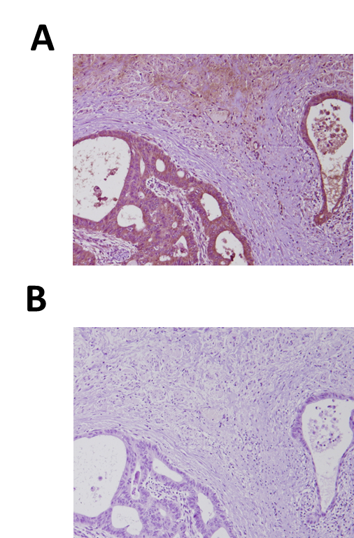

Online Figure 1. Controls of NOD1 immunohistochemical analysis. A section of colon cancer tissue incubated with NOD1 and mouse IgG antibodies was used as positive control (A). Negative control was a section of colon cancer tissue incubated with a mouse IgG instead of NOD1 antibody (B).

Online Figure 2
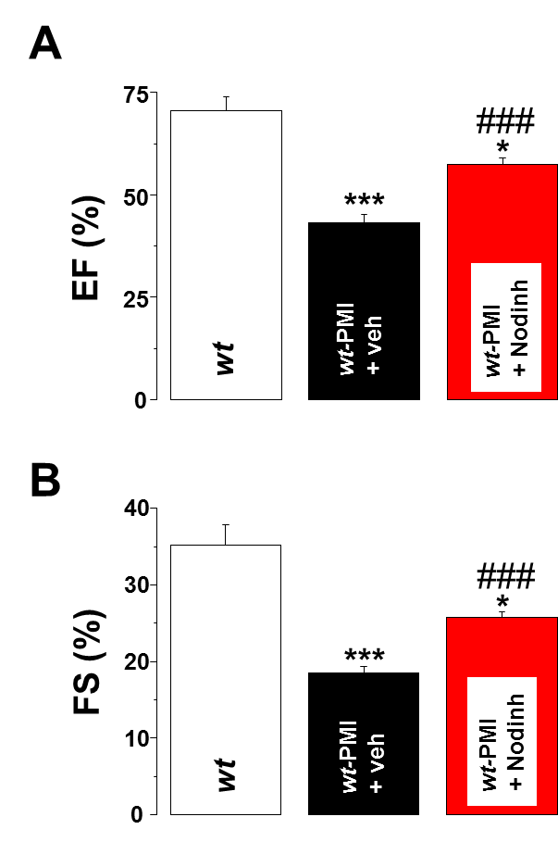
Online Figure 2. Selective blockade of NOD1 prevents cardiac dysfunction in wt-PMI mice. Mice were treated for 6 weeks (3 times weekly) with the NOD1 inhibitor, Nodinhibit-1 (5 µmol/L; wt-PMI Nodinh) or vehicle (wt-PMI veh). Histograms represent the mean values of the ejection fraction (A, EF) and fractional shortening (B, FS) obtained in wt (N = 5), wt-PMI veh (N = 4) and wt-PMI Nodinh (N = 5). *P < 0.05; ***P < 0.001 vs. wt; ###P < 0.001 vs. wt-PMI veh.
Online Figure 3
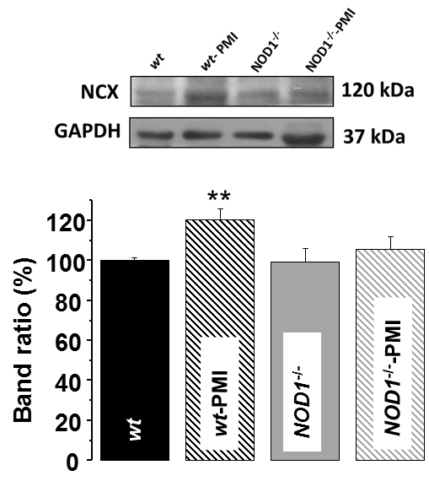
Online Figure 3. NCX is over-expressed in wt-PMI hearts but not in NOD1^{-/-}-PMI hearts. Upper panel shows a representative western blot of NCX and GAPDH expression obtained from hearts of wt (N = 9), wt-PMI (N = 9), NOD1^{-/-} (N = 8), and NOD1^{-/-}-PMI (N = 8) mice. Lower panel; quantification of densitometry data. Results show mean ± SEM (band ratio) expressed as percentage vs. wt. **P < 0.01.

Online Figure 4.
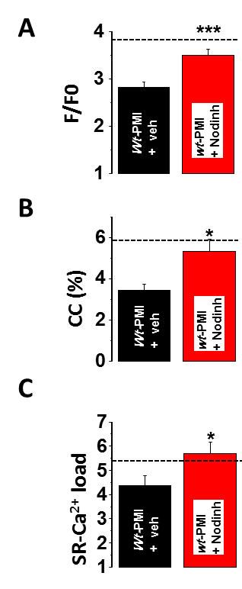
Online Figure 4. Selective blockade of NOD1 prevents [Ca²⁺]_{i} transients, cell contraction and SR Ca²⁺ SR load impairment in wt-PMI mice. Mice were treated for 6 weeks (3 times weekly) with the NOD1 inhibitor, Nodinhibit-1 (5 µmol/L; wt-PMI Nodinh) or vehicle (wt-PMI veh). Histograms represent (A) mean values of peak fluorescence [Ca²⁺]_{i} transients (F/F0), (B) cell contraction (CC, %), and (C) caffeine-evoked [Ca²⁺]_{i} transients amplitude (SR-Ca²⁺ SR load, F/F0) obtained in vehicle and treated cells (n = 38 cells/4 mice) and wt-PMI Nodinh-treated cells (n = 44 cells/5 mice). *P < 0.05; ***P < 0.001 vs. wt-PMI veh. Dotted lines represent wt mean values.

Online Figure 5
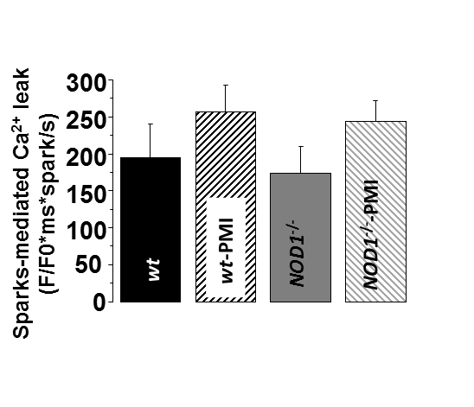
Online Figure 5. Spark-mediated Ca²⁺ leak is not modified by HF. Average spark-mediated Ca²⁺ leak in quiescent cells from wt (n = 20 cells/4 mice) wt-PMI (n = 49 cells/8 mice), NOD1^{-/-} (n = 24 cells/4 mice) and NOD1^{-/-}-PMI (n = 37 cells/8 mice). Results show mean ± SEM.

Online Figure 6
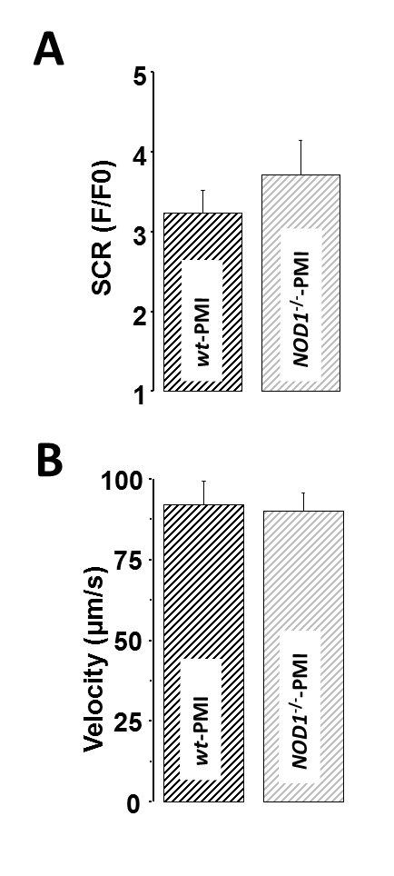
Online Figure 6. Spontaneous Ca²⁺ release (SCR) amplitude and Ca²⁺ waves’ velocity are similar between wt-PMI and NOD1^{-/-}-PMI cells. Mean values of (A) SCR amplitude and (B) velocity of Ca²⁺ waves in both experimental groups. Results show the mean ± SEM.

Online Figure 7.
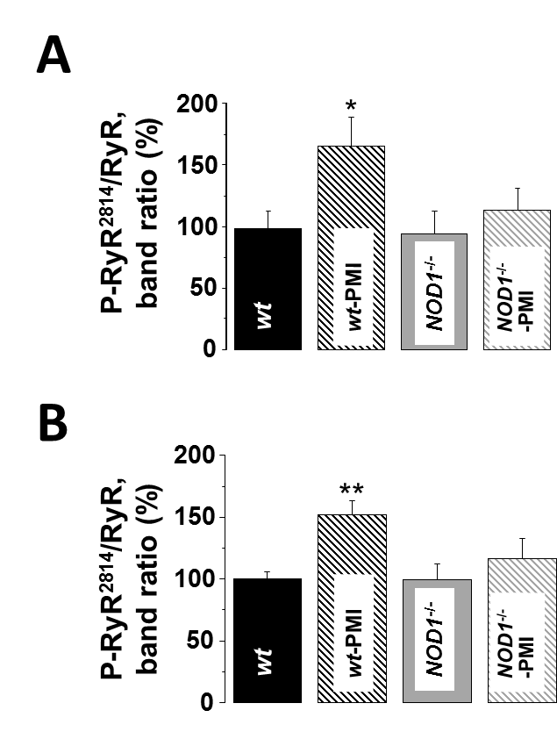
Online Figure 7. Cardiac RyR phosphorylation at Ser²⁸⁰⁸ and Ser²⁸¹⁴ is enhanced in wt-PMI mice but not in NOD1^{-/-}-PMI mice. Histograms show the mean values of phosphorylated RyR at Ser²⁸⁰⁸ (A) and Ser²⁸¹⁴ (B) vs. total RyR in wt (N = 9 mice) wt-PMI (N = 10 mice), NOD1^{-/-} (N = 8 mice) and NOD1^{-/-}-PMI (N = 12 mice). Results show the mean ± SEM. *P < 0.05; **P < 0.01 vs. wt.

Online Figure 8
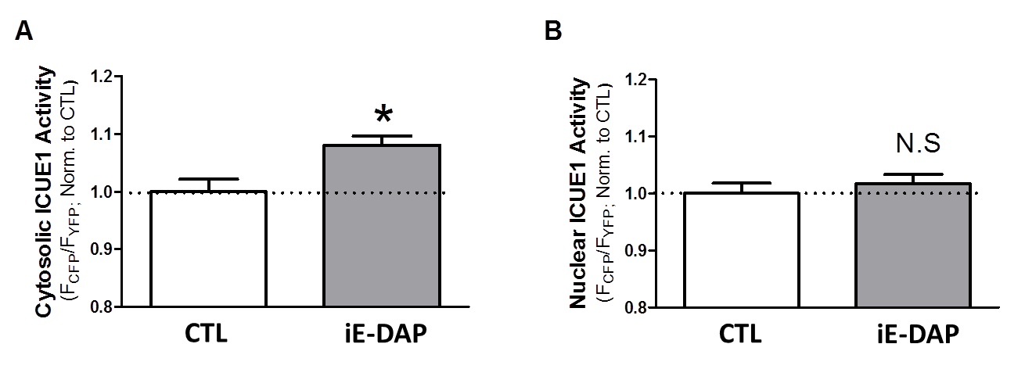

Online Figure 8. NOD1 activation increases cAMP levels. (A) Mean ICUE1 signal in cytosol at baseline (CTL = vehicle) and after 24 hours of treatment with C12-iEDAP (iE-DAP; 40 µmol/mL). (B) Mean ICUE1 signal in the nucleus in the same cells and conditions. CTL (n = 22/3 rabbits) and iE-DAP (n = 17/3 rabbits). *P < 0.05 vs. CTL.

Online Figure 9

Online Figure 9. PKA and CaMKII inhibitors prevent systolic calcium dysregulation and cell contractility impairment induced by NOD1 activation. Histograms represent (A) mean values of peak fluorescence [Ca²⁺]_{i} transients (F/F0) and (B) cell contraction (CC), obtained in cardiomyocytes treated for 1-2 h with vehicle (n = 12/3 mice), with iE-DAP (40 µg/mL; n = 13/ 3 mice), with iE-DAP (40 µg/mL) + KT-5720 (KT, 2 µmol/L; n = 12/3 mice) or with iE-DAP (40 µg/mL) + KN-93KT (KN, 1 µmol/L; n = 12/3 mice). Data show the mean ± SEM. **P < 0.01 vs. Veh, #P < 0.05; ##P < 0.01 vs. iE-DAP.

Online Figure 10
Online Figure 10. Increased levels of NOD1 co-immunoprecipitate with RyR in wt-PMI cardiac tissue. Rapid perfusion of cardiomyocytes with iE-DAP alters Ca²⁺ handling. A, Upper panel; representative blots of protein levels of NOD1 co-immunoprecipitated with cardiac RyR in wt, wt-PMI and wt-PMI mice treated with Nodinhibit-1 (5 µmol/L; wt-PMI Nodinh). Lower panel; histograms show the mean values ± SEM (N = 3-7; **P < 0.01 vs. wt; #P < 0.05 vs. wt-PMI). B, Left panel; fluorescence of [Ca²⁺]_{i} transients profiles obtained in vehicle (<0.001% DMSO, Veh), iE-DAP (20 µg/mL, iE) or in the presence of the inactive analogue of iE-DAP; iE-Lys (20 µg/mL, iE-Lys) treated cardiomyocytes. Right panel; mean values of the [Ca²⁺]_{i} transients amplitude (F/F0) in Veh (n = 16/3 mice), iE-DAP (n = 10 cells/3 mice) or iE-Lys (n = 8 cells/3 mice) treated cells. C, Mean values of cell contraction (CC, %, left panel) and caffeine-evoked [Ca²⁺]_{i} transients amplitude (SR-Ca²⁺ load, F/F0, right panel) obtained in Veh (n = 16 cells/3 mice), iE-DAP (n = 10 cells/3 mice) or iE-Lys (n = 7 cells/3 mice) treated cells. Data show the mean ± SEM. **P < 0.01; ***P < 0.001 vs Veh.

Online Figure 11
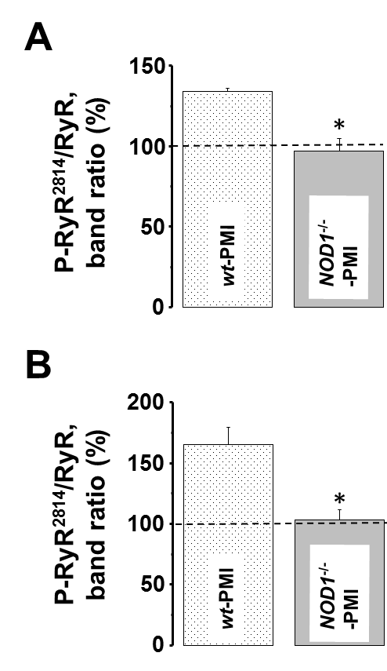
Online Figure 11. Cardiac RyR phosphorylation at Ser²⁸⁰⁸ and Ser²⁸¹⁴ is enhanced in wt-PMI mice but not in NOD1^{-/-}-PMI mice after isoproterenol treatment. Histograms show the mean values of phosphorylated RyR (A-B) vs. total RyR wt-PMI (N = 3 mice) and NOD1^{-/-}-PMI (N = 3 mice) in hearts isolated from mice injected intraperitoneally 0.2 mg/kg of isoproterenol. Results show the mean ± SEM. Dotted lines represent wt mean values. *P < 0.05 vs. wt-PMI.

Online Table 1. Ca²⁺-spark characteristics in intact cells.
 | Peak  (F/F0) | FWHM  (µm) | FDHM  (ms) | N  (cells/mice)
wt | 1.45±0.04 | 2.59±0.13 | 31.87±1.74 | 20/4
wt-PMI | 1.67±0.03** | 3.22±0.14** | 33.16±1.37 | 49/8
NOD1^{-/-} | 1.55±0.05 | 2.84±0.10 | 34.46±1.86 | 24/4
NOD1^{-/-} -PMI | 1.59±0.02* | 3.15±0.07* | 35.79±1.15 | 37/8

FWHM: Full width at half maximum; FDHM: Full duration at half maximum; *P < 0.05; **P < 0.01 vs. wt.

References:
1. Delgado C, Ruiz-Hurtado G, Gomez-Hurtado N, Gonzalez-Ramos S, Rueda A, Benito G, Prieto P, Zaragoza C, Delicado EG, Perez-Sen R, Miras-Portugal MT, Nunez G, Bosca L, Fernandez-Velasco M. Nod1, a new player in cardiac function and calcium handling. Cardiovasc Res. 2015;106:375–386
2. Pereira L, Cheng H, Lao DH, Na L, van Oort RJ, Brown JH, Wehrens XH, Chen J, Bers DM. Epac2 mediates cardiac beta1-adrenergic-dependent sarcoplasmic reticulum ca2+ leak and arrhythmia. Circulation. 2013;127:913–922.

